From March 31 to April 4, Ken, Vera, Magda, and Adilia visited various communities in Nicaragua to meet with Kenoli’s partner organizations. It was a deeply moving experience: in every place, we saw organized families, determined to move forward despite the challenges.

**ODESAR: Clean water, bright future**

High up in the mountains of Nicaragua, the community of El Portón celebrated a transformative milestone: for the first time, they have access to drinking water 24 hours a day. With the support of ODESAR, a Kenoli partner, and in coordination with the local municipality and health unit, the families worked together to build a water system that now guarantees health and well-being.

Francela, a young woman from the community, led the inauguration ceremony, reminding everyone that water not only cleans but also strengthens. This collective achievement demonstrates what is possible when there is organization, will, and solidarity. ***Access to drinking water is not just an improvement, it's the foundation for a life with health, dignity, and new possibilities!***

**ALDEMA: Cultivating life in the dry corridor**

In San Francisco and La Manzana, communities affected by the drought in the municipality of San Lucas, Madriz, families are facing hunger, with organization and collective work. With the support of ALDEMA, they are establishing family gardens and chicken coops that improve nutrition and health, especially for children.

Here, where water is scarce and challenges are great, what abounds is community commitment. Thanks to the support of Kenoli and ALDEMA, these families are not only growing food: they are cultivating dignity, well-being, and a future. ***In the midst of the drought, hope blossoms when there is solidarity and organization!***

**Hogar Luceros: Strength and hope from day one**

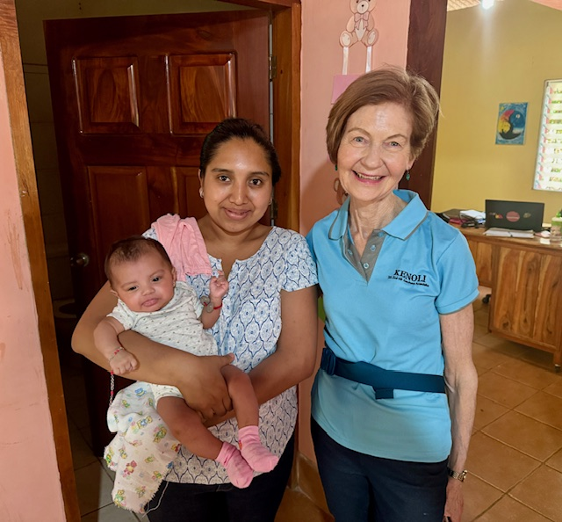

In Camoapa, the program Una Vida a la Vez, driven by Hogar Luceros, supports pregnant women and young mothers during the first 1,000 days of their children’s lives. Magdalena, one of the participants, shared how exercises, massage, and breastfeeding have strengthened her baby and given her confidence as a mother.

In addition to early support, Hogar Luceros offers academic reinforcement, art classes, computer skills, dance, and English. It is a space for comprehensive care, where love and education go hand in hand to build a fairer future with greater opportunities. ***This is how hope is planted for a better future!***

**CEPROSI: Dignified housing, transformed life**

In the rural areas of Nicaragua, CEPROSI is making possible what many families dreamed of: leaving behind zinc houses to build block homes. Fátima, a gender promoter, was able to build her home with a loan and subsidy, and today she inspires other women in her community to do the same.

Her daughter Dalia, who suffered from malnutrition in her childhood, is now a healthy teenager thanks to CEPROSI's nutrition program. This organization demonstrates that with access to resources and training, women not only improve their living conditions but also lead processes of community change. ***A dignified home and a toilet provide dignity and health to families!***

**Casa-Pueblito: Women changing their destiny in Santa Julia**

In El Crucero, the women of Santa Julia have walked a path of struggle and transformation. Supported by Casa-Pueblito, they went from living without basic services to leading cooperatives, learning about their rights, and obtaining property titles in their names.

Thanks to training in gender and organization, many have emerged from the silence imposed by domestic violence. Today, domestic violence has significantly diminished and the women plant, produce, and make decisions in their communities. Santa Julia is a living example of how organization and empowerment can change everything. ***When women unite, there are no limits to what they can achieve!***